## 2012 NY SHARKS PRO SERIES OFFENSIVE PLAYS

***NOTE: Running Holes are as follows: 7 TE 5 LT 3 LG 1 C 2 RG 4 RT 6 TE 8***

***In Pro Series TB is the 3 Back, FB is the 2 Back***

***Below are the Pro Series plays going both left or right divided by the* /**

Pro Right 21 Dive / Pro Left 32 Dive

Pro Right 34 Delay / Pro Left 23 Delay

Pro Left 22 Cross / Pro Right 31 Cross

Pro Left 35 Cross / Pro Right 26 Cross

Pro Right 26 Pitch / Pro Left 35 Pitch

Pro Left Fake 33 - 26 Pitch / Pro Right Fake 24 – 35 Pitch

Pro Right 35 Lead / Pro Left 26 Lead

Pro Right Fake 33 - Z-Sweep / Pro Left Fake 24 – Z Sweep

Pro Right 28 Power Sweep / Pro Left 37 Power Sweep

Pro Right Fake 24 - TE Dump / Pro Left Fake 33 – TE Dump

Pro Right Cross- Boot Lt Run / Pro Left Cross -Boot Rt Run

Pro Left Cross –Boot Left TE Out / Pro Right Cross – Boot Rt X Corner

Pro Right Fake 24 - Z Post

Pro Right Quick Pass

Pro Left Fake 32, Y Drag

Pro Left Fake 32 – 19 Boot, Z Reverse

Basic Terminology & Play Numbering System

# Pro Right 21 Dive

Position

C

RG

RT

TE (Y)

FL (Z)

LG

LT

SE (X)

QB (1)

FB (2)

TB (3)

Notes

Description

BLOCK UPFIELD ON MIDDLE LINEBACKER OR NOSE GUARD.

BLOCK OUTSIDE

BLOCK OUTSIDE

BLOCK DEFENSIVE END OUTSIDE, IF THERE IS NO END, THEN BLOCK

OUTSIDE LINEBACKER.

BLOCK CORNERBACK TO THE OUTSIDE.

BLOCK OUTSIDE

BLOCK OUTSIDE

BLOCK CORNERBACK TO THE OUTSIDE.

TAKE SNAP AND HANDOFF BALL TO 2-BACK AT THE 1-HOLE

TAKE HANDOFF AT 1-HOLE AND UPFIELD.

RUN THROUGH 2-HOLE TRY TO GET UPFIELD AND BLOCK A LINEBACKER OR SAFETY.

# PRO RIGHT -34 DELAY

Position

C

RG

RT

TE (Y)

FL (Z)

LG

LT

SE (X)

QB (1)

FB (2)

TB (3)

Notes

Description

BLOCK UPFIELD, EITHER NOSE GUARD OR MIDDLE LINEBACKER, WHICHEVER COMES

FIRST.

BLOCK LEFT

BLOCK RIGHT

GET UPFIELD AND TRY TO BLOCK LINEBACKER.

BLOCK INSIDE, TRY TO GET INSIDE AND BLOCK OUTSIDE LINEBACKER.

BLOCK LEFT

BLOCK LEFT

GET DEEP AND BLOCK CORNER OUTSIDE.

TAKE SNAP, FAKE HANDOFF TO 2-BACK AND 2-HOLE, THEN MAKE HANDOFF TO 3-

BACK AT 4-HOLE.

TAKE FAKE HANDOFF THROUGH 2-HOLE, THEN MAKE BLOCK ON LINEBACKER.

WAIT FOR 2- BACK TO CLEAR THEN TAKE HANDOFF AT 4-HOLE. WILL HAVE TO

PRACTICE TIMING FOR BEST RESULTS WITH THIS PLAY.

# Pro Left 22 Cross

Position

C

RG

RT

TE (Y)

FL (Z)

LG

LT

SE (X)

QB (1)

Description

BLOCK UPFIELD ON MIDDLE LINEBACKER OR NOSE GUARD.

BLOCK OUTSIDE

BLOCK OUTSIDE

BLOCK DEFENSIVE END OUTSIDE, IF THERE IS NO END, THEN BLOCK

OUTSIDE LINEBACKER.

BLOCK CORNERBACK TO THE OUT SIDE.

BLOCK OUTSIDE

BLOCK OUTSIDE

BLOCK CORNERBACK TO THE OUTSIDE.

TAKE SNAP, FAKE HANDOFF TO 3 -BACK GOING TO 3-HOLE. HAND BALL TO 2 -BACK

GOING THROUGH 2-HOLE. QB MUST TURN BACK TO THE DEFENSE AND KEEP BALL

HIDDEN DURING FAKE FOR THIS TO WORK.

TAKE ONE HALF-STEP TO LEFT, THIS WILL GIVE A DELAY SO THAT THE 3-BACK CAN

CROSS. THEN TAKE HANDOFF AT 2-HOLE.

CROSS BEHIND QB, HELP QB FAKE THE HANDOFF THEN BLOCK DEFENSIVE

LINEMEN ON LEFT SIDE.

FB (2)

TB (3)

# PRO LEFT - 35 CROSS

Position

C

RG

RT

TE (Y)

FL (Z)

LG

LT

SE (X)

Description

BLOCK UPFIELD ON MIDDLE LINEBACKER OR NOSE GUARD.

BLOCK UPFIELD

BLOCK UPFIELD

BLOCK DEFENSIVE END INSIDE, IF THERE IS NO END, THEN CLOSEST

LINEBACKER OR DEFENSIVE LINEMEN.

BLOCK INSIDE ON OUTSIDE LINEBACKER.

BLOCK INSIDE

BLOCK INSIDE

RUN DEEP ROUTE AND DRAW CORNER COVERAGE, THEN TURN INSIDE

AND TRY TO BLOCK SAFETY.

FAKE HANDOFF TO 2-BACK AT 2-HOLE, TURN AND HAND BALL TO 3-BACK

CROSSING TO THE 5-HOLE. MUST KEEP BACK TOWARDS DEFENSE AND KEEP BALL

HIDDEN.

TAKE FAKE HANDOFF AT 2-HOLE, THEN BLOCK ON LINEBACKER.

TAKE A HALF-STEP TO THE RIGHT TO CREATE A DELAY BEFORE CROSSING

WITH 2 -BACK. TAKE HANDOFF TO THE 5-HOLE. WILL HAVE TO PRACTICE TIMING

FOR BEST RESULTS.

QB (1)

FB (2)

TB (3)

# PRO RIGHT 26 PITCH

Position

C

RG

RT

TE (Y)

FL (Z)

LG

LT

SE (X)

QB (1)

FB (2)

TB (3)

Notes

Description

BLOCK UPFIELD, EITHER NOSE GUARD OR MIDDLE LINEBACKER, WHICHEVER COMES

FIRST.

BLOCK LEFT

BLOCK LEFT

BLOCK DEFENSIVE END OUTSIDE

BLOCK CORNERBACK OUTSIDE.

BLOCK LEFT

BLOCK LEFT

GET DEEP TO MIDDLE OF FIELD AND BLOCK SAFETY.

TAKE SNAP, THEN QUICKLY TURN AND PITCH TO THE 2-BACK GOING TO THE 6-

HOLE.

SWEEP TO 6-HOLE AND TAKE PITCH FROM QB. FOLLOW 3-BACK AS LEAD

BLOCKER.

LEAD BLOCK THROUGH 6-HOLE FOR 2- BACK. BLOCK FIRST DEFENDER THAT TRIES

TO CLOSE HOLE.

# PRO LEFT FAKE 33-26 PITCH

Position

C

RG

RT

TE (Y)

FL (Z)

LG

LT

SE (X)

QB (1)

FB (2)

TB (3)

Notes

Description

BLOCK LEFT (TRYING TO GET DEFENSE TO FOLLOW THE FAKE HANDOFF)

BLOCK LEFT (TRYING TO GET DEFENSE TO FOLLOW THE FAKE HANDOFF)

BLOCK LEFT (TRYING TO GET DEFENSE TO FOLLOW THE FAKE HANDOFF)

BLOCK LEFT (TRYING TO GET DEFENSE TO FOLLOW THE FAKE HANDOFF)

BLOCK CORNER OUTSIDE

BLOCK LEFT (TRYING TO GET DEFENSE TO FOLLOW THE FAKE HANDOFF)

BLOCK LEFT (TRYING TO GET DEFENSE TO FOLLOW THE FAKE HANDOFF)

BLOCK CORNER OUTSIDE

FAKE HANDOFF TO 3-BACK AT 3-HOLE, TURN AND SPRINT TO RIGHT SIDE, THEN

PITCH TO 2-BACK. AFTER PITCH, TRY TO STAY AHEAD OF 2-BACK AND BLOCK

DOWNFIELD.

SWEEP OUTSIDE FOR PITCH AT 6-HOLE.

TAKE FAKE HANDOFF AT 3-HOLE. ONCE THROUGH THE LINE OF SCRIMMAGE

# PRO RIGHT 35 LEAD

Position

C

RG

RT

TE (Y)

FL (Z)

LG

LT

SE (X)

QB (1)

FB (2)

TB (3)

Notes

Description

BLOCK UPFIELD, EITHER NOSE GUARD OR MIDDLE LINEBACKER, WHICHEVER COMES

FIRST.

BLOCK RIGHT

BLOCK RIGHT

BLOCK DEFENSIVE END OUTSIDE

RUN DEEP TO MIDDLE OF FIELD AND BLOCK SAFETY.

BLOCK RIGHT

BLOCK RIGHT

BLOCK CORNER OUTSIDE

TAKE SNAP, MAKE QUICK HANDOFF TO 3-BACK HEADING TO 5-HOLE.

LEAD BLOCKER FOR 3-BACK, MUST GET TO HOLE VERY QUICKLY AND BLOCK THE

FIRST DEFENDER THAT ENTERS THE HOLE. TRY TO BLOCK MORE THAN ONE

DEFENDER IF POSSIBLE.

TAKE HANDOFF AND GET THROUGH 5-HOLE VERY QUICKLY. FOLLOW THE

LEAD BLOCK OF 2-BACK AND BREAK TO THE OPEN HOLE CREATED BY 2-BACK.

# PRO RIGHT FAKE 33 -Z SWEEP

Position

C

RG

RT

TE (Y)

FL (Z)

LG

LT

SE (X)

QB (1)

FB (2)

TB (3)

Notes

Description

BLOCK RIGHT.

BLOCK RIGHT.

BLOCK RIGHT.

BLOCK RIGHT.

RUN SWEEP TO LEFT OUTSIDE, FOLLOW LEAD BLOCK OF 2-BACK.

BLOCK RIGHT.

BLOCK RIGHT.

BLOCK CORNERBACK OUTSIDE.

TAKE SNAP, FAKE HANDOFF TO 3-BACK AT 3-HOLE, THEN TURN AND HANDOFF TO

Y SWEEPING TO THE LEFT. AFTER HANDOFF MAKE BLOCK ON DEFENDER

FOLLOWING THE FLANKER.

LEAD BLOCK OUTSIDE, TRY TO GET BLOCK ON OUTSIDE LINEBACKER.

TAKE FAKE HANDOFF THROUGH 3-HOLE, THEN BLOCK.

# Pro Right 28 Power Sweep

Position

C

RG

RT

TE (Y)

FL (Z)

LG

LT

SE (X)

QB (1)

FB (2)

TB (3)

Notes

Description

Snap ball, block MLB

Double team DT with RT

Double team DT with RG

Block inside on OLB or DE

Block outside on CB

Block Outside

Block Outside

Block Inside on SAFETY

Take snap, make handoff to 2-BACK

Take handoff, sweep to 8-hole, follow lead block

Make lead block on outside on either OLB or DE

# PRO RIGHT FAKE 24 -TE DUMP

Position

C

RG

RT

TE (Y)

FL (Z)

LG

LT

SE (X)

QB (1)

FB (2)

TB (3)

Notes

Description

Block up.

Block up.

Block up.

At snap drift behind line to the left side, take Dump pass

Block back inside on linebacker.

Block in.

Block in.

Take Corner outside, block.

Fake 24 Dive, Bootleg to the right, pass back to the TE going to the left.

Take fake to the 4-hole, block.

Block TE’s hole on the line.

# PRO RIGHT FAKE 24- BOOT LFT RUN

Position

C

RG

RT

TE (Y)

FL (Z)

LG

LT

SE (X)

QB (1)

FB (2)

TB (3)

Notes

Description

BLOCK RIGHT, EITHER NOSE GUARD OR MIDDLE LINEBACKER, WHICHEVER COMES

FIRST.

BLOCK RIGHT

BLOCK RIGHT

BLOCK DEFENSIVE END INSIDE.

GET TO MIDDLE OF FIELD AND MAKE BLOCK ON SAFETY.

BLOCK RIGHT

BLOCK RIGHT

GET INSIDE AND MAKE A CUT BLOCK ON OUTSIDE LINEBACKER.

TAKE SNAP, FAKE HANDOFF TO 2-BACK GOING TO 4-HOLE, THEN TURN AND SWEEP

LEFT. FOLLOW THE LEAD BLOCK OF 3-BACK.

TAKE FAKE HANDOFF TO THE 4-HOLE AND MAKE A BLOCK.

LEAD BLOCK OUTSIDE FOR THE QB BOOTLEG. MAKE A BLOCK ON THE FIRST

DEFENDER TO TRY TO CLOSE THE HOLE.

# PRO RIGHT, CROSS- BOOT LEFT RUN

Position

C

RG

RT

TE (Y)

FL (Z)

LG

LT

SE (X)

QB (1)

FB (2)

TB (3)

Description

Block up.

Block up.

Block up.

Block up.

Take CB downfield, then block.

Block in.

Block in.

Take CB downfield, then block.

Take snap, fake 22 Cross, Bootleg back to the 5-hole, use block of the

3-back

Take fake, sell play at the line, draw Linebacker inside and block.

Lead block for the QB at 5-hole, should block FS coming up to stop

play.

Notes

# PRO LEFT- CROSS- BOOT LEFT -TE OUT

Position

C

RG

RT

TE (Y)

FL (Z)

LG

LT

SE (X)

QB (1)

FB (2)

TB (3)

Notes

Description

Pass Block.

Pass Block.

Pass Block.

Release block, run 15 yard out route.

10 Yard slant route.

Pass Block.

Pass Block.

20 Yard Post route.

At snap Fake 22 Cross, Bootleg out to the 7-hole, look for open

wide out, if covered keep running the bootleg.

Take the 22 Cross Fake and block at line.

Cross and drift left, wait for the dump off Screen.

# PRO RIGHT FAKE 24 - Z POST

Position

C

RG

RT

TE (Y)

FL (Z)

LG

LT

SE (X)

QB (1)

FB (2)

TB (3)

Notes

Description

PASS BLOCK

PASS BLOCK

PASS BLOCK

RUN 15-YARD OUT ROUTE.

RUN 15-YARD POST ROUTE.

PASS BLOCK

PASS BLOCK

RUN 15-YARD OUT ROUTE.

FAKE HANDOFF TO 2-BACK AT 4-HOLE, THEN DROP BACK AND LOOK FOR FLANKER

ON POST, IF SAFETY COVERS THE MIDDLE OF THE FIELD LOOK FOR TE OR SPLIT END

ON OUT ROUTES. QB ALSO HAS OPTION TO RUN INSTEAD OF PASS.

TAKE FAKE HANDOFF AT 4-HOLE, THEN BLOCK ON ANY PASS RUSHERS.

PASS PROTECT ON THE RIGHT SIDE, STOP ANY DEFENSIVE PENETRATION,PROVIDE

EXTRA TIME FOR QB TO THROW THE PASS.

# PRO RIGHT QUICK PASS

Position

C

RG

RT

TE (Y)

FL (Z)

LG

LT

SE (X)

QB (1)

FB (2)

TB (3)

Notes

Description

PASS BLOCK.

PASS BLOCK.

PASS BLOCK.

RUN 5-YARD OUT ROUTE.

RUN 10-YARD OUT ROUTE.

PASS BLOCK.

PASS BLOCK.

RUN 15-YARD POST ROUTE.

TAKE SNAP THEN TAKE 3-STEP DROP. PICK OPEN RECIEVER THEN MAKE PASS. QB

SHOULD LOOK IN THIS ORDER: Z,Y,X.

PASS BLOCK

PASS BLOCK

# PRO LEFT FAKE 32 Y DRAG

Position

C

RG

RT

TE (Y)

FL (Z)

LG

LT

SE (X)

QB (1)

FB (2)

TB (3)

Notes

Description

PASS BLOCK

PASS BLOCK

PASS BLOCK

RUN DRAG ROUTE ACROSS MIDDLE OF FIELD. TRY TO GET 5-6 YARDS

DEEP & RUN BETWEEN SAFETY AND LINEBACKERS.

PASS BLOCK

PASS BLOCK

RUN 10-YARD OUT ROUTE.

TAKE SNAP, FAKE HANDOFF TO 3-BACK AT 2-HOLE, ROLL OUT TO RIGHT 2-3 YARDS

THEN LOOK FOR TE CLEARING OVER THE MIDDLE. PASS TO TE, IF COVERED LOOK

FOR SPLIT END ON THE OUT ROUTE OR RUN THE BALL.

BLOCK OUTSIDE TO LEFT. KEEP DEFENSIVE RUSH FROM GETTING TO QB.

TAKE FAKE HANDOFF THROUGH 2-HOLE, THEN BLOCK.

# PRO LEFT, FAKE 32 – 19 Boot - Z REVERSE

Position

C

RG

RT

TE (Y)

FL (Z)

LG

LT

SE (X)

QB (1)

FB (2)

TB (3)

Description

Block up.

Block up.

Block IN.

Release block at line, take outside LB or CB.

At snap, sprint to the right side, cross behind QB for the Reverse.

Take ball to the 6-hole, use blockers.

Block up.

Block up.

Block for CB to outside

Take snap, fake to the 3-back, run 17 bootleg.

Hand off to the 4-back coming back around for the Reverse.

At snap, lead block to the 6-hole for the Reverse.

Take fake to the 2-hole, block at line.

Notes

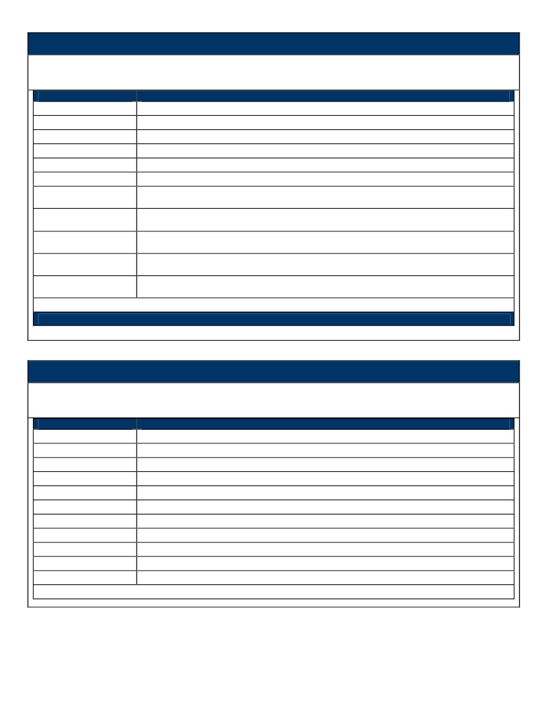Basic Terminology

This section contains definitions for basic football terms and abbreviations used in this playbook.

Term

C CENTER

RG , LG RIGHT GUARD , LEFT GUARD

RT , LT RIGHT TACKLE , LEFT TACKLE

TE (Y) TIGHT END

QB QUARTERBACK

FB (2) FULLBACK

TB (3) TAILBACK

LOS or Line of

Scrimmage

Hole

SE (X)

FL (Z)

Description

This is the yard line that the ball is placed on. The offensive formation must

have a minimum of 7 players on the LOS.

This is the ground between or outside the offensive line. All holes are numbered,

with even numbers being on the right and odd numbers to the left.

Split End. Receiver that is split out to the opposite side of the Tight End and is

one the Line of Scrimmage

Flanker. Receiver that is split out on the same side as the Tight End, however

this receiver position in OFF the Line of Scrimmage.

Play Numbering System

This section contains explanation of how the plays are named

Term

Play Example

Description

Pro Right 21 Dive

“Pro Right” = The Offensive Formation

“2” = The 2-BACK is getting the ball

“1” = The hole the 2-BACK is going thru

“Dive” Type of run (See run types Below)

Play #2

Pro Right Quick Pass

“Pro Right” = The Offensive Formation

“Quick Pass” = No Bootleg, just straight drop and pass

Dive = No double team or Lead Block. Lead = Lead Blocker Power = Line is Double Teaming one